**Project Name:**

**SEDAP – South Eastern Data Analytics Platform**

**Company Name: Media Com Sys.**

**Aim: TO Create Analytics Platform for Customer’s watch time data.**

1. Download this file from github link provided below and start this project
2. You do not need any other documentation except this video

Position 1 – Entry_ID

Position 2 – Customer_ID  
Position 3 – Customer_First_Name

Position 4 – Customer_Last_Name

Position 5 – Channel_Number

Position 6 – Start_Watch_Time

Position 7 – End_Watch_Time

Position 8 – Customer_Age

1. Collect Valid data in proper collection – make sure you have no duplicate element

**Validation Rules:**

|  |  |
| --- | --- |
| Field | Validation Rules |
| Entry_ID | Non negative integer – should not repeat in single file |
| Customer_ID | Non-Negative Integer |
| Customer_First_Name | Text Only, String, 30 Character long, No Special characters |
| Customer_Last_Name | Text Only, String, 30 Character long, No Special characters |
| Channel_Number | Ranger from 100 to 1500 – non negative integer |
| Start_Watch_Time | Time value from 0000 to 2359. Last two digits cannot be greater than 59, first two cannot be greater than 23 |
| End_Watch_Time | Time value from 0000 to 2359. Last two digits cannot be greater than 59, first two cannot be greater than 23 End time is greater than start time |
| Customer_Age | Age validation – non negative integer range from 15 to 121. |

1. Collect Invalid data as CSV Format – attach Error Message with original data in each row and Send this data to “SEDAP.MANUAL.ANALYSIS.QUEUE” in ActiveMQ

**Original Data Row**: 19,315,Treva,Womack,730,2850,880,53

**Error Message Row**: 19,315,Treva,Womack,730,2850,880,53, Invalid End Time Format

1. Now on Day 3 – Video 3 – We have Valid set of Data. We are inserting data in DB. Please get the table schema from Github.

<https://github.com/rishitrainer/SEDAP/blob/master/sedap.sql>

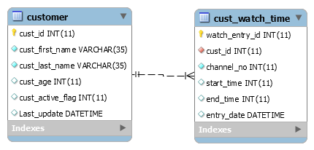

1. Customer has “One to Many” relationship with cust_watch_time table
2. If Customer_id is not provided in Input file, then it will be created with Auto-increment PK CUST_ID
3. If CUST_ID is provided in File, use the same for insertions.
4. If Data is already present for customer – update customer record with new data present in file
5. CUST_WATCH_TIME table will have many entries for single customer
6. Using Batch insert of normal insert is your choice, but make sure that the data should not be repeated in case of exception.

**Additional Requirement:**

1. **Can you send an email to yourself when batch completes?**

Tip: Use Mail API